A Polymerization Reactor

Polymer production is one of the most common processes that rely on inferential sensing. Due to impurities in raw materials, side reactions cannot be effectively modelled and first principles-based models are inaccurate. In addition, online measuring technology is often either very expensive or not available for properties such as Melt Index or Density, thus process management must rely on laboratory measurements obtained at irregular sampling intervals.

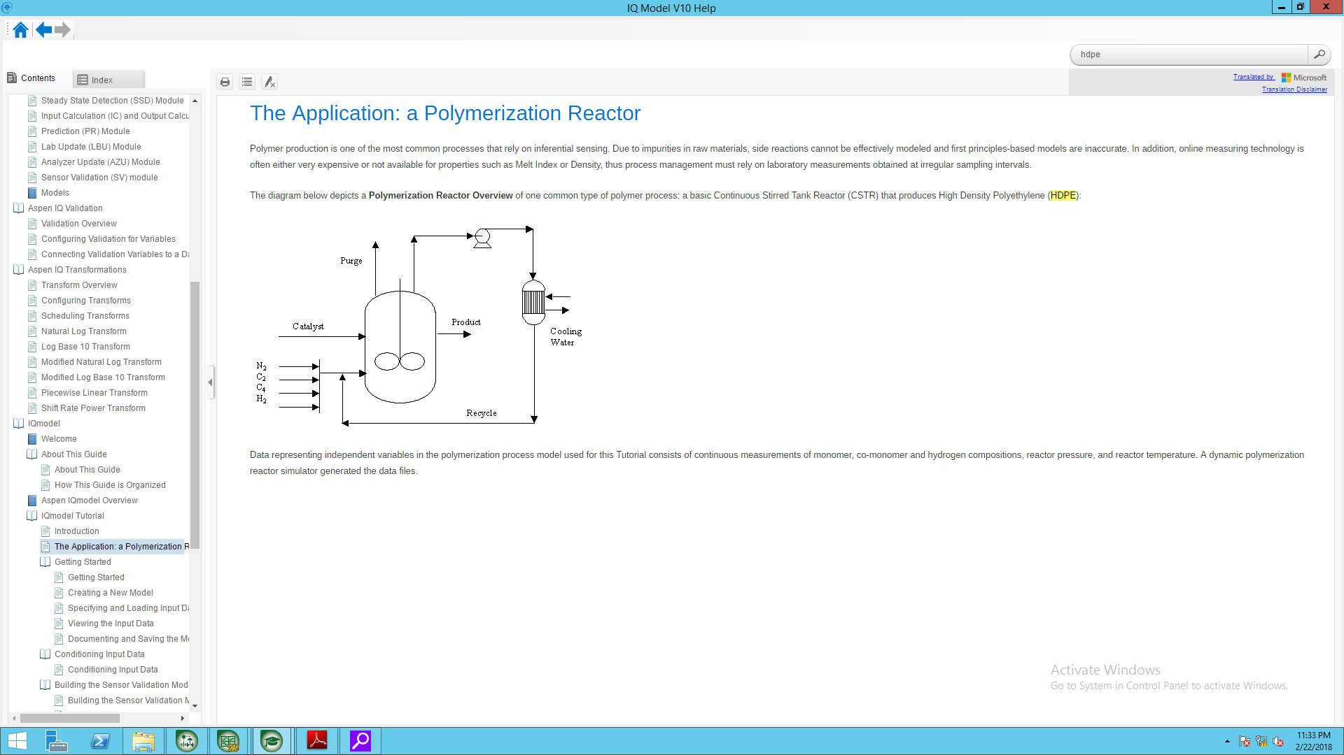The diagram below depicts a Polymerization Reactor Overview of one common type of polymer process: a basic Continuous Stirred Tank Reactor (CSTR) that produces High Density Polyethylene (HDPE):

Data representing independent variables in the polymerization process model used for this Tutorial consists of continuous measurements of monomer, co-monomer and hydrogen compositions, reactor pressure, and reactor temperature. A dynamic polymerization reactor simulator generated the data files.